|  |
| --- |
|  |
| **Mentor Messenger**  November/December 2017 |
|  |
|  |
| Education is the most powerful weapon which you can use to change the world.  **-Nelson Mandela** |
|  |

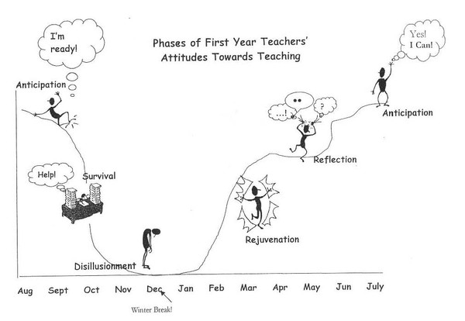**The Survival Phase!**



|  |
| --- |
|  |
| During the fourth and fifth month… -Novice Regional Seminar begins November 15th. Don’t forget to sign up on My PGS or www.washoe.truenorthlogic.com if you are not completing it at your school site!  -Review [Nevada Academic Content Standards (NVACS)](http://www.doe.nv.gov/Standards_Instructional_Support/Nevada_Academic_Content_Standards/) and your assessments to ensure alignment.  -Check out the WCSD Mentor Program on Pinterest  -Explore 63,000 Resources School specific things to know… -Procedures/expectations for holiday celebrations.  -Are there specific things you need to know when leaving your classroom for break in order to make cleaning easier for custodial staff?  -Hours school is open and accessible to teachers during break. |
|  |

***Why include this?*** *The first year of teaching may feel like a roller coaster for many new teachers. Recognizing the phases of first year teaching can help you to reflect upon your experience and understand that you are not alone.*

**The Disillusionment Phase:** After weeks of nonstop work and stress, new teachers enter the disillusionment phase. The intensity and length of the phase varies among new teachers. The extensive time commitment, the realization that things are probably not going as smoothly as they want and low morale contribute to this period of disenchantment. New teachers begin questioning both their commitment and their competence. Many new teachers get sick during this phase. During this phase, classroom management is a major source of distress. At this point, the accumulated stress of the first-year teachers, coupled with months of excessive time allotted to teaching, often brings complaints from family members and friends. This is a very difficult and challenging phase for new entries into the profession. They express self-doubt, have lower self-esteem and question their professional commitment. In fact, getting through this phase may be the toughest challenge they face as a new teacher.

**Daily tips to stay happy and healthy:**

**Monday:** It’s a universally acknowledged truth that no one likes Mondays, so begin your day calmly.

* Try relaxing for two minutes before your students arrive in the morning. Visualize the day ahead going as well as possible because this is good for the soul.

**Tuesday:** Tuesday is a good day to pay attention to the early signs that you are becoming stressed.

* Half way through the day, why not reduce muscle tension? Tense your shoulders without straining, then relax while breathing deeply. Feel the stress fading away.

**Wednesday:** You’re right in the middle of the week and making sure you feel refreshed is important: sleep it vital.

* Avoid the enemies of sleep. Keep a regular sleep schedule, have a relaxing bedtime routine, eat healthy and get regular exercise.

**Thursday:** The best medicine for a happy Thursday is laughter; have a giggle with colleagues or listen to your favorite comedy show.

* Laughing has wide-ranging benefits, improving cardiovascular health and helping you connect with others so start the day with a chuckle.

**Friday:** When Friday arrives it is time to switch off that mental filter. You’re almost at the weekend and it’s time to relax and wind down from work.

Make sure you eat regularly and stay hydrated. This is particularly important (but less likely) when we are busy and stressed.

***It’s That Time! Have You Signed Up For Classes?***

**New Teacher Academy at:**

[**www.washoe.truenorthlogic.com**](http://www.washoe.truenorthlogic.com)

My PGS Registration Mentoring and Induction

